Soft Bodies, Hard Structures
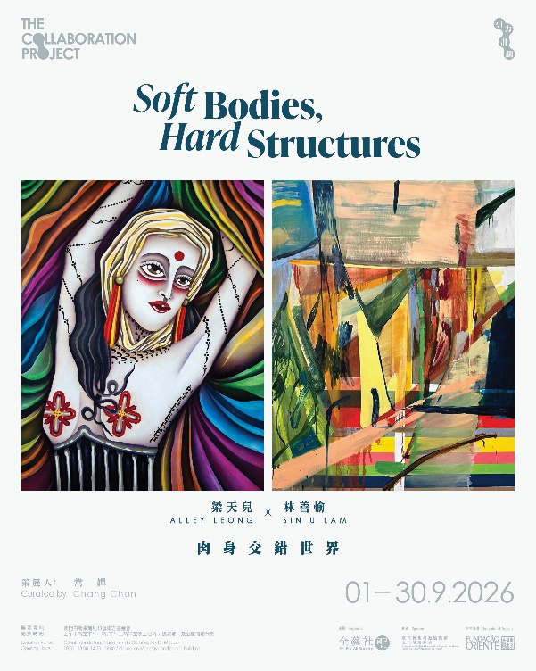
The inaugural edition of The Collaboration Project brings together the artistic practices of two young artists, Alley Leong and Sin U Lam. Although painting is the primary medium for both, they have followed very different personal and artistic paths, developing distinct visual languages of their own.
Alley Leong is a self-taught artist. She began her career as a tattoo artist before moving her practice onto the canvas. Born without a left forearm, she has experienced from an early age the gaze, judgement, and scrutiny that bodily difference can invite. This experience led her to confront the relationship between the body and the self, gradually shaping a distinctive way of seeing at herself, others, and the world. Young female figures appear frequently in her paintings. Their bodies are fluid and supple, rendered in vivid colours, while the eyes—including the red marks between the brows, sometimes understood as a “third eye”—are often given particular emphasis. Together, these elements construct a visual world situated somewhere between the body, imagination, and spirituality.
Sin U Lam has taken a very different path. Formally trained in fine art, she began with sculpture before eventually turning to painting. Her sculptural training continues to inform her sensitivity to space and form. Rather than depicting recognisable objects or landscapes, she transforms them into colour, gesture, layers, and relationships that unfold across the picture plane. Drawing on memory, lived experience, and her perception of the environments around her, her paintings gradually shed the clarity of their original forms, leaving behind sensations that may be difficult to name, yet remain deeply embedded within the body.
Their artistic trajectories are different, and so are their visual languages. Yet neither artist seeks to depict an objectively existing world. Instead, they attempt to reconstruct on the canvas the worlds they perceive and generate through the body, memory, imagination, and lived experience.
Leong begins with direct bodily experience, reimagining the possibilities of the body—and the very ideas of a “complete body” and a “perfect body.” She creates a distinctive visual universe in which bodies are fluid, forms can transform, and boundaries remain unstable. The soft and liberated bodies in her paintings challenge the norms and frameworks that the real world imposes upon what is considered a “normal” body. Spiritual presences that cannot be directly seen are also given form within her paintings.
Lam, by contrast, enters through space. She projects her memories and sensations onto spatial memories, allowing emotions and affect to take shape within space. Her paintings possess a strong sense of structure and architectural quality, yet they are not representations of specific places. Instead, they resemble a sedimentation of perception: experiences that cannot be seen, but have already been felt, are ultimately preserved through the layering and accumulation of paint on canvas. They reflect the body as a mode of being—how we inhabit the world through our bodies, moving through time and space, intimacy and solitude, possession and loss. How we experience the world, in turn, shapes the world we inhabit and construct for ourselves.
The two artists offer two distinct ways of seeing, shaped by two different lived experiences. Through this collaboration, the two young artists move closer to one another’s perceptual worlds through dialogue, discussion, and co-creation. They observe one another through the lens of their own experiences, paint each other’s portraits, and, through being seen by the other, turn their gaze back upon themselves. In the intersection of these two worlds, new experiences and possibilities continue to emerge.

