Artists bio

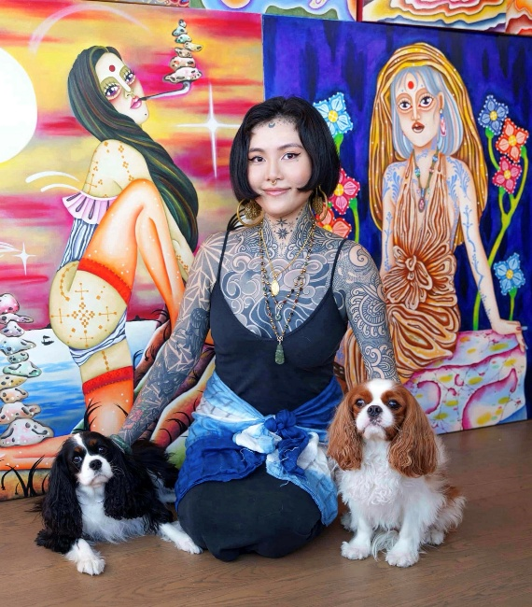
Alley Leong (b. 1996, Macau, China) is a self-taught artist, tattoo artist, practitioner, and an individual born with a physical disability.
After working as a tattoo artist for six years, Leong turned her attention to oil painting. Born with a congenital limb difference, her exploration of bodily experience has remained central to her artistic practice. Through her signature depictions of female figures adorned with distinctive body tattoos, and her attempts to give visible form to the invisible energies of the spiritual realm, Leong transforms the canvas into a ritual space for self-exploration and the pursuit of the divine within.
Drawing upon esoteric and religious traditions, her practice explores the flow and transformation of spiritual and corporeal energies within the human body. Beginning with her own embodied experience, Leong seeks to uncover the codes underlying the essence of human existence.

Email: alleyalleyleong@gmail.com
Instagram: @alleyalleyleong

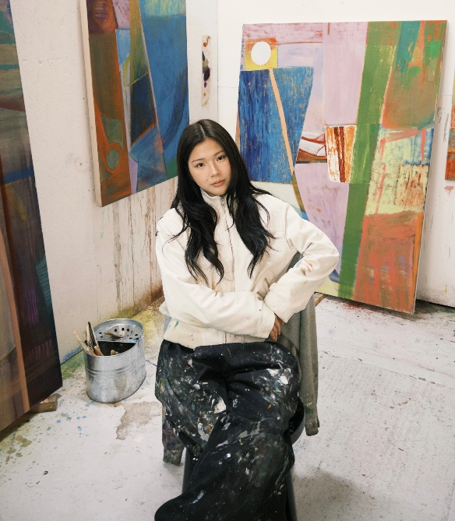
Sin U Lam (b. 2001, Macau, China) is a painter living and working in London. She holds a BA in Fine Art from Chelsea College of Art (2024).
Lam’s practice explores painting as a process of growth, accumulation, and transformation. Working with colour, gesture, and material, she allows each painting to develop through an exchange between intention and the inherent qualities of the materials themselves. Layers are built, disturbed, removed, and exposed, allowing traces of earlier decisions to remain within the surface. Interested in the physical life of materials—their weight, resistance, texture, and capacity to hold time and touch—Lam responds perceptively to what emerges through the process rather than imposing a predetermined image. Her paintings balance control and chance, permanence and change, allowing colour, surface, and form to continually shift between emergence and disappearance.

Email: sulam102601@gmail.com
Instagram: @sulaaam

Curator: Chan Chang
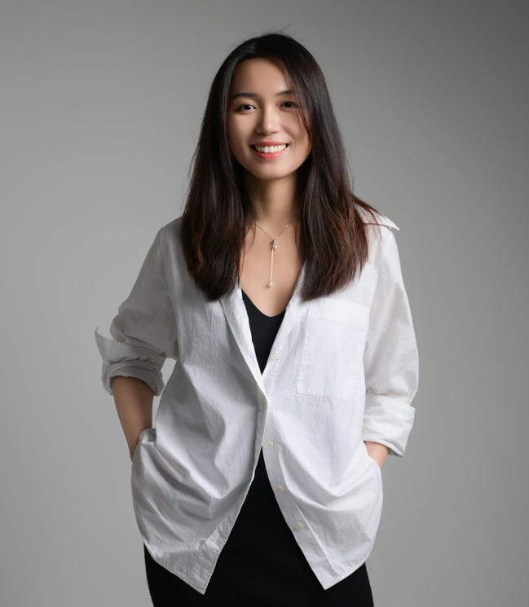
Chang Chan is a Macao-based independent curator and art critic. She holds an MA in Arts & Cultural Management from King’s College London and served as the curator of the Macao Pavilion at the 60th International Art Exhibition of La Biennale di Venezia. Her curatorial practice spans different regions, exploring the increasingly prevalent spiritual and existential crises of contemporary neoliberal commercial society, as well as the boundaries of what art can reach in response to them. She is a regular contributor to art media in Hong Kong and Macao.

